Chapter 5

Product Design

**Background**

New product development has a strong marketing component, so this chapter may pique the interest of the marketing majors in the class. An important theme to emphasize in this chapter is that, for most businesses, new product development is an ongoing exercise and crucial to long-term survival. It is not typically an activity that is pursued once per decade. Furthermore, as time passes, we will expect to see the topic of environmentally friendly designs take on more and more significance.

**Class Discussion Ideas**

1. Ask the students to brainstorm about potential principles of good design. The following list from the Bad Designs web site (www.baddesigns.com) may be helpful to guide the discussion.

* Devices should follow a consistent rule.
* When simple things have signs, it is usually evidence that they are not well designed.
* Things that need to be distinguished from each other should differ by more than just a single feature.
* The shape of an object should reveal how it is to be used.
* A device should be designed so that it will not be confused with devices that operate under different operating principles. (Watch out "Sports Illustrated Football Phone")
* Make sure your design provides displays of everything a person needs to see.
* When you design a device, take the viewpoint of the user.
* When you design an object, you need to consider the environment that it is used in.
* Do not add an extra step to a task for the sake of aesthetics.
* Take a hint from people's behavior. If they find it convenient to walk in a particular place, put in a sidewalk - not a barrier. This is an example of "natural" design.
* When you design something, you need to test it with a variety of people to make sure it does not have any annoying side effects.
* A well-designed object can be designed to both look good and be easy to use.
* When you design something, you need to think about the great differences in the capabilities of the people that will need to use it.
* When you have several similar displays close together and lined up, people will confuse them with each other.
* Place a control next to the device it controls.

2. Have students brainstorm about new products or services that they have thought about and would like to see on the market. Instructors should add that it is very difficult to see a new product succeed in the marketplace. The data suggest that the probability of success is quite low. Whether in large innovative companies like 3M or in an individual’s garage, many products have made it all the way through research, patenting, design, and small production runs only to fail in the end. Think about books. If 400,000 are written annually in the U.S. alone, how many sell more than 100 copies? More than 1000?

**Active Classroom Learning Exercises**

1. Using a product and service familiar to the students, ask them to split into small groups to discuss how customers are involved in the design of the product or service. For most products, of course, the level of involvement is quite low. Have the student describe how the design process for a product could be enhanced by the involvement of the customer and how that might be organized. Have each student group report its ideas to the whole class.

2. Split the class into small groups. Have each group select a service business and then identify the “moments of truth” for that company. How should operations be designed to meet or exceed customers’ expectations during those moments? Have each student group report its ideas to the whole class.

**Company Videos**

1. *Product Design at Regal Marine (7:36)*

Factors that affect product design for Regal Marine include: customer tastes, trends, competitive products, material innovations, government regulations, and taxes. The company looks for market niches and develops products that meet its company mission and can fit into the existing distribution network. Students should recognize that new product development is a way of life for Regal. Products only last for 3-7 years, and the firm introduces about four new products every year. In fact, they have a dedicated cross-disciplinary *ongoing* new product development team. Important features of the new product development process for Regal include: (1) designing for manufacturability so that production can easily be ramped up and investment can be recovered quickly, (2) using computer-aided design (CAD), (3) involving suppliers in the design process, (4) testing new parts in a lab, (5) avoiding environmentally negative components, and (6) searching for common components that are already used in existing boats.

Prior to showing the video, instructors might ask the students to list key features of the new product development process for Regal. Follow-up discussion could flush out the importance of these issues, most of which are likely relevant for most manufacturing firms. An alternative discussion might explore the life cycles for Regal and compare them to perceived life cycles of other types of products. Yet another discussion might create a comparison between the new product development process for manufacturing vs. service industries. In particular, what might a service firm focus on that a manufacturing company like Regal might not?

**Cinematic Ticklers**

1. *The Hudsucker Proxy: A Comedy of Invention (Tim Robbins, Jennifer Jason Leigh, Paul Newman), Warner Brothers Home Video, 1994*

Toward the middle of the movie we see the new product development process of the Hula Hoop, from the sales pitch to the board of directors through final acceptance by the market. It’s a fast-paced sequence of scenes sprinkled with humor throughout.

2. *The Simpsons, Season 2: “Oh Brother, Where Art Thou?,” 20th Century Fox Video, 2002 (1990-1991)*

Homer is put in charge of designing a new vehicle for his half-brother’s car company. Needless to say, some of his ideas are far-fetched.

3. *The Simpsons, Season 12: “HOMR,” 20th Century Fox Video, 2009 (2000-2001)*

This short scene shows new product testing, culminating with Homer ignoring the food after ingesting a hunger suppressant—not because he wasn’t hungry but because the suppressant made him blind.

**Presentation Slides**

INTRODUCTION (5-1 through 5-10)

Slide 10: From the Global Company Profile, Regal Marine is the third-largest boat manufacturer in the world. An important reason for this success is an aggressive emphasis on new product development, sparked by changing consumer tastes, material changes, and marine engineering improvements. Regal introduces as many as six new boat models in one year. Computer-aided design (CAD) contributes significantly to speedy development of new models while encountering relatively few problems. Boats are produced on an assembly line, with parts being delivered on a just-in-time basis.



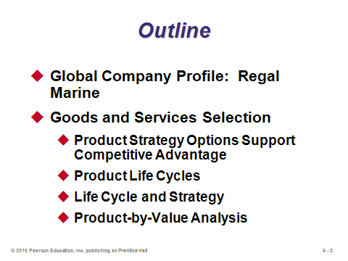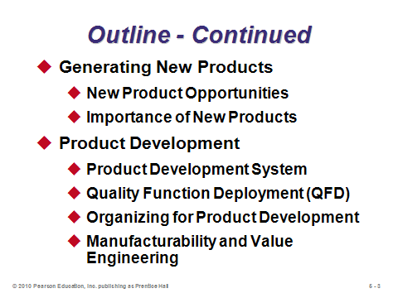

**5-1 5-2 5-3**

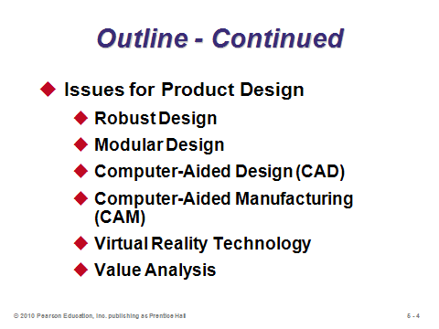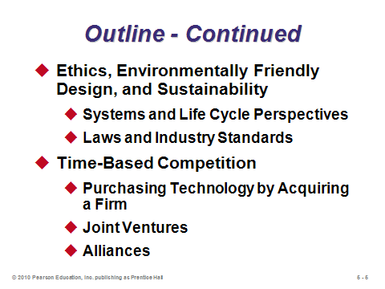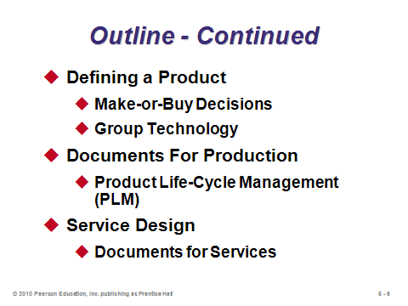

**5-4 5-5 5-6**

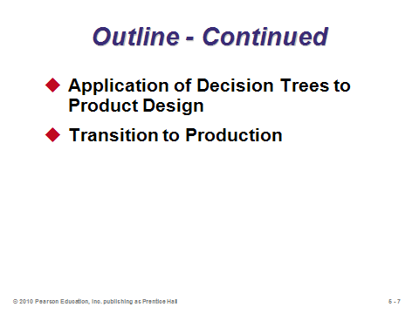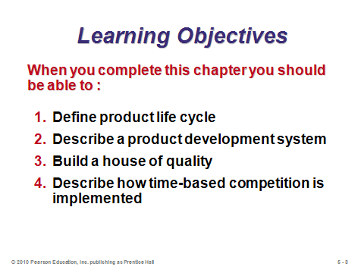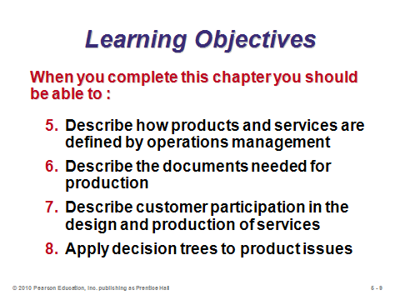

**5-7 5-8 5-9**

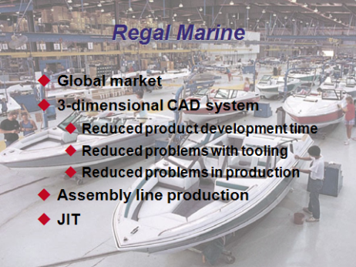

**5-10**

GOODS AND SERVICES SELECTION (5-11 through 5-22)

Slides 11-12: The *product decision* is defined as the selection, definition, and design of products.

Slide 13: The corporate strategies of differentiation, low cost, and rapid response first seen in Chapter 2 directly impact the product decisions that firms make.

Slides 14-19: First introduced in Chapter 2, product life cycles are revisited in these slides. Slide 15 (Figure 5.1) shows how sales, cost, and profit tend to evolve as a product progresses through its life cycle. The firm makes the most profit during the maturity and decline phases; however, as the decline phase is inevitable, new products must be developed continuously. Slides 16-19 provide characteristics of each of the four life cycle phases. Accordingly, R&D and innovation efforts tend to focus more on the product itself in the first two phases, while those efforts tend to focus more on the process (how to make the product or provide the service) in the last two phases.

Slides 21-22: Product-by-value analysis applies the Pareto principle (focus on the critical few, not the trivial many) to the product mix. By ranking products in decreasing order of their individual dollar contribution to the firm (selling price minus direct cost), and also examining their total annual dollar contribution, managers can determine which products should receive the most investment resources. Slide 22: In this little example, the recliner would be ranked first, followed by the love seat, then the arm chair, and finally the foot stool. Notice that a ranking based on total annual contribution would not necessarily be the same as that for individual contribution, so both units of analysis should be considered.

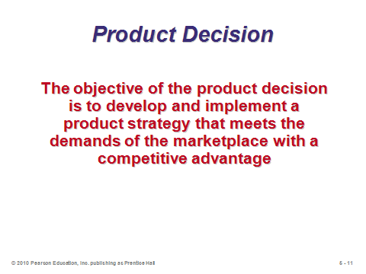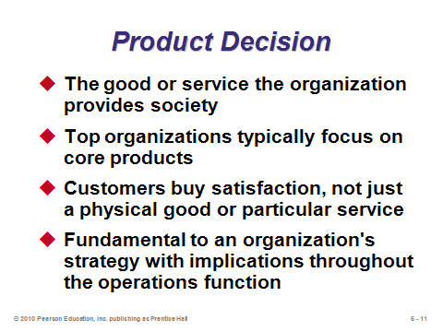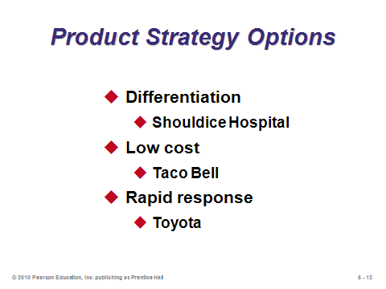

**5-11 5-12 5-13**

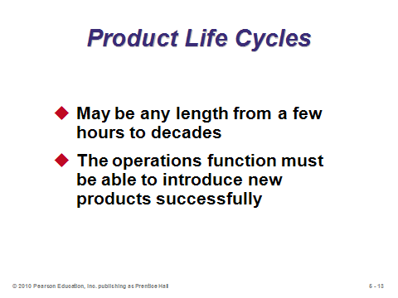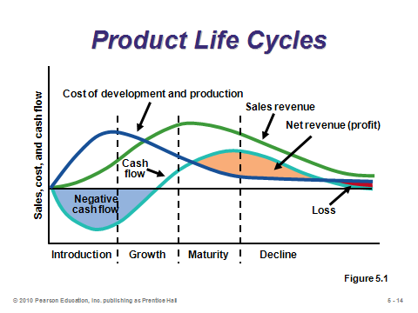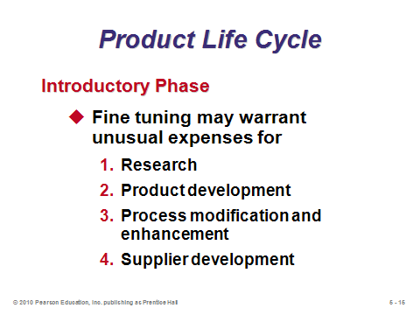

**5-14 5-15 5-16**

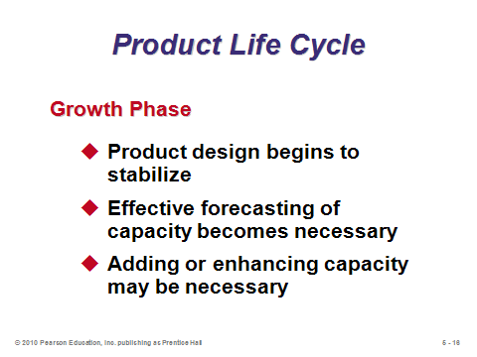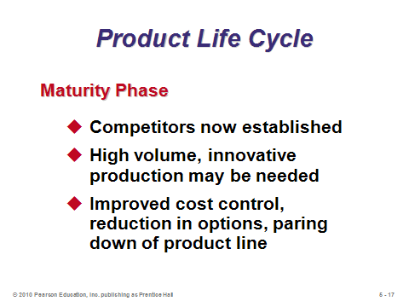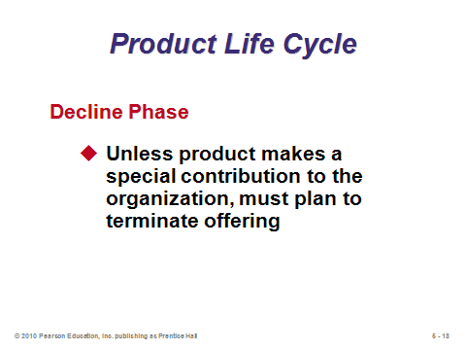

**5-17 5-18 5-19**

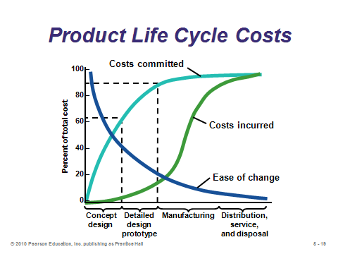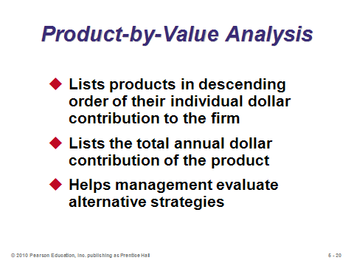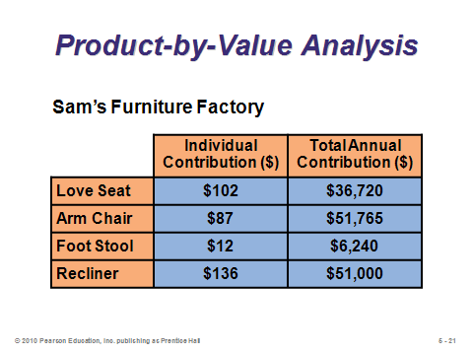

**5-20 5-21 5-22**

GENERATING NEW PRODUCTS (5-23 through 5-26)

Slide 23: This slide explains how new products may arise.

Slide 24: This slide (Figure 5.2(a)) is a very important one to show students that firms must constantly be developing new products to become and remain industry leaders.

Slides 25-26: World-class firms continually search for new products. Slide 25 (Figure 5.2(b)): Disney World innovates with new parks, rides, and attractions to boost attendance. Slide 26 (Figure 5.2(c)): Much of Cisco’s growth has come from new *non-networking* products.

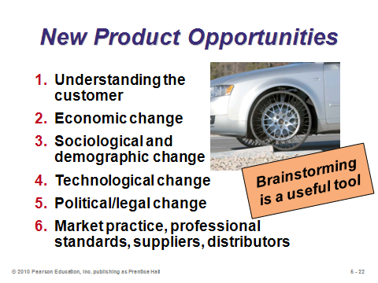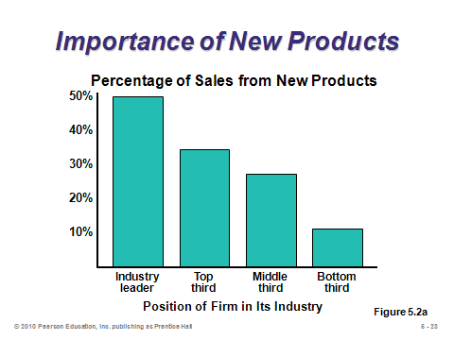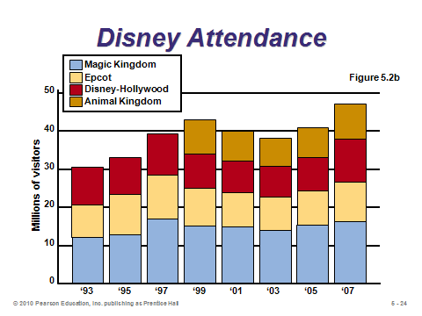

**5-23 5-24 5-25**

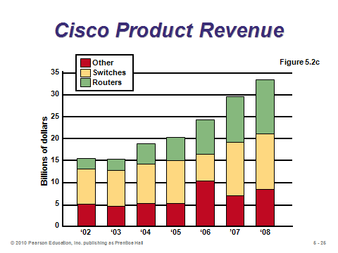

**5-26**

PRODUCT DEVELOPMENT (5-27 through 5-43)

Slide 27: This slide (Figure 5.3) shows the stages of product development. See how the product development team provides front-end and back-end functions to the output from the design and engineering teams.

Slides 28-29: *Quality Function Deployment* (QFD) is a process for determining customer requirements (customer “wants”) and translating them into the attributes (the “hows”) that each functional area can understand and act on. Slide 28 identifies the seven basic steps for building a QFD *house of quality*, a graphic technique that utilizes a planning matrix to relate customers “wants” to “how” the firm is going to meet those “wants.” Slide 29 displays the framework for a generic house of quality.

Slides 30-38: These slides present Example 1 from the text, which builds a full house of quality for a new camera design.

Slide 39: Another use of QFD is to show how the quality effort will be *deployed*. This slide (Figure 5.4) shows that the *design characteristics* of House 1 become the inputs to House 2, which are satisfied by *specific components* of the product. These are the inputs to House 3, which are satisfied through particular *production processes*. These become the inputs to House 4, to be satisfied by a *quality plan* that will ensure conformance of those processes. The quality plan is a set of specific tolerances, procedures, methods, and sampling techniques that will ensure that the production process meets the customer requirements.

Slides 40-41: These slides describe four approaches to organizing for product development. Among these, the conventional wisdom seems to be to use the team approach.

Slides 42-43: Manufacturability and value engineering activities are concerned with improvement of design and specifications at the research, development, design, and production stages of product development. In other words, design engineers should not just create a product that works, but they should also think about *how* the product will be made and try to design it so that it is as easy and cheap to manufacture as possible. Slide 42 identifies potential benefits in addition to cost reduction. Slide 43 (Figure 5.5) provides an example of applying value engineering to a bracket design. Each time the bracket is redesigned and simplified, the firm can produce it for less.

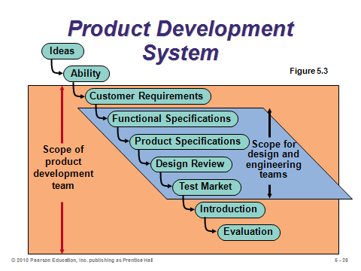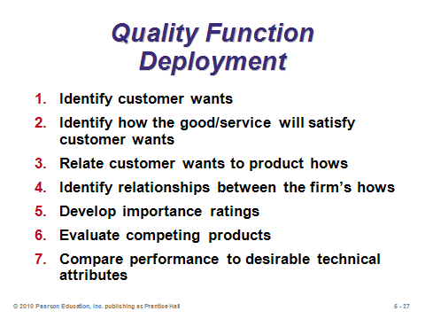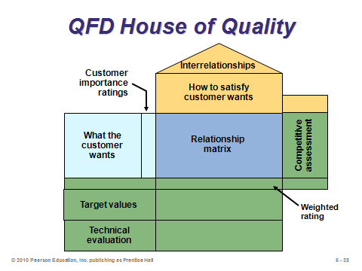

**5-27 5-28 5-29**

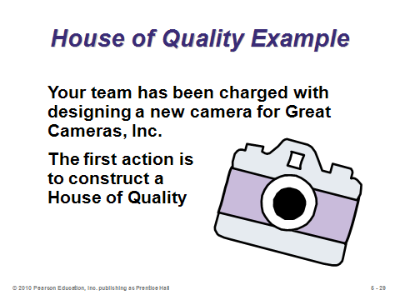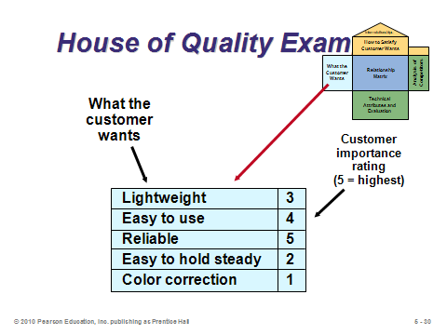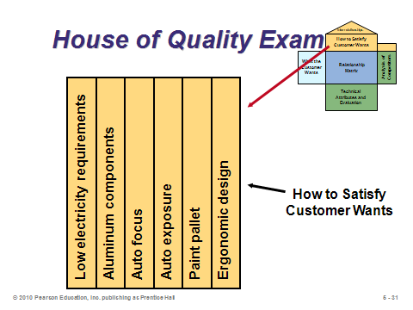

**5-30 5-31 5-32**

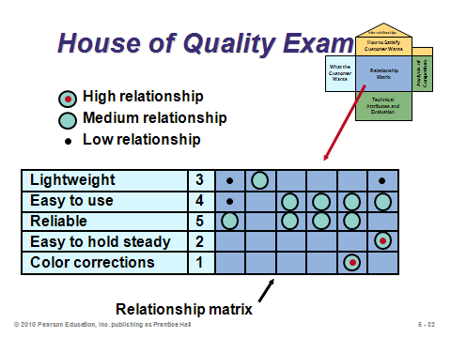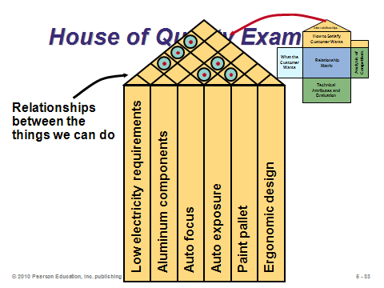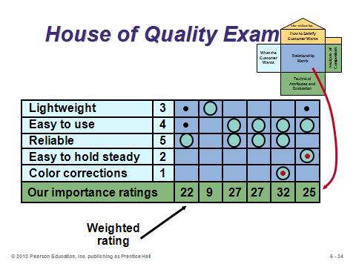

**5-33 5-34 5-35**

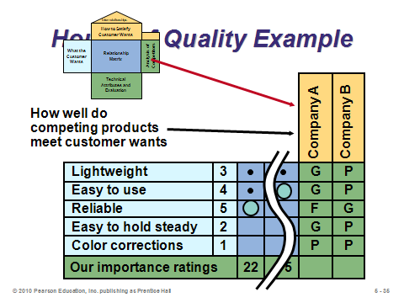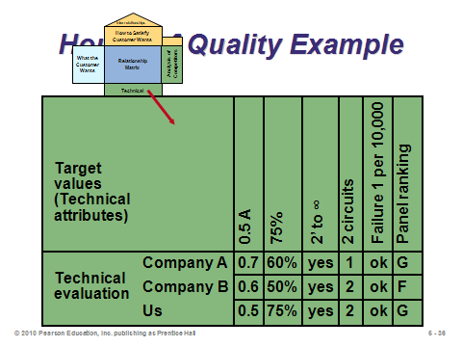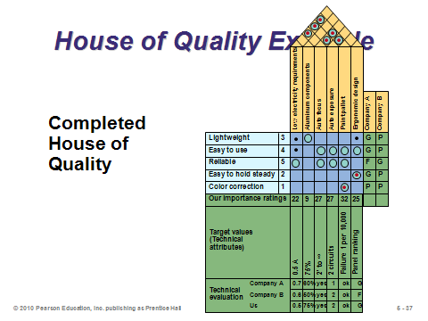

**5-36 5-37 5-38**

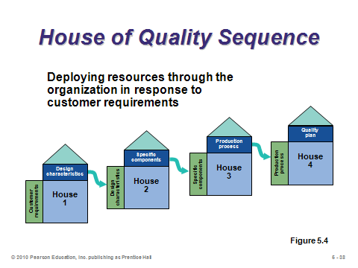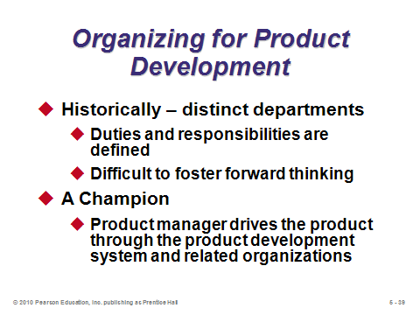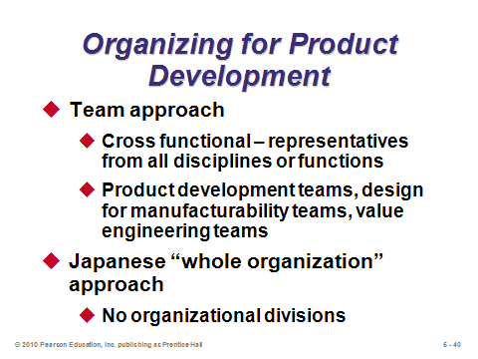

**5-39 5-40 5-41**

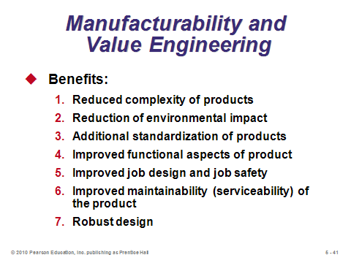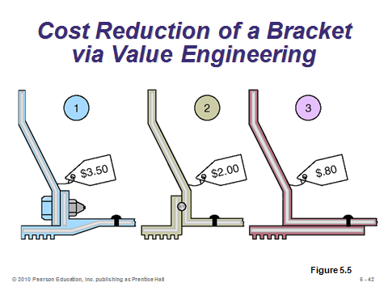

**5-42 5-43**

ISSUES FOR PRODUCT DESIGN (5-44 through 5-52)

Slide 44: This slide identifies seven techniques that are important to the design of a product.

Slide 45: A *robust design* can be produced to requirements even with unfavorable conditions in the production process.

Slide 46: A *modular* *design* has parts or components of a product that are subdivided into modules that are easily interchanged or replaced. Combinations of a few modules can produce a wide variety of final product configurations. Modular design helps firms implement *postponement* (see Chapters 7 and 11).

Slides 47-48: Slide 47 describes *computer-aided design* (CAD). The use and variety of CAD software is extensive and is rapidly expanding. The speed and ease with which sophisticated designs can be manipulated, analyzed, and modified with CAD makes review of numerous options possible before final commitments are made. Slide 48 identifies several extensions of CAD.

Slides 49-50: Slide 49: *Computer-aided manufacturing* (CAM) is the use of information technology to control machinery. When CAD information is translated into instructions for CAM, the result of these two technologies is called CAD/CAM. Slide 50 identifies benefits of CAD and CAM. CAD/CAM removes substantial detail work, allowing designers to concentrate on the conceptual and imaginative aspects of their task.

Slide 51: This slide describes *virtual reality*, a visual form of communication in which images substitute for reality and typically allow the user to respond interactively.

Slide 52: This slide describes *value analysis*, which seeks improvements but takes place *during* (not before) the production process. Sometimes issues arise after production has begun that could not be anticipated ahead of time.

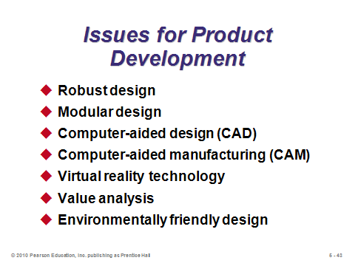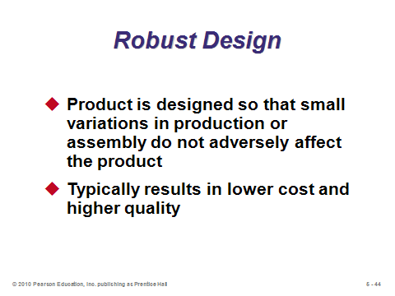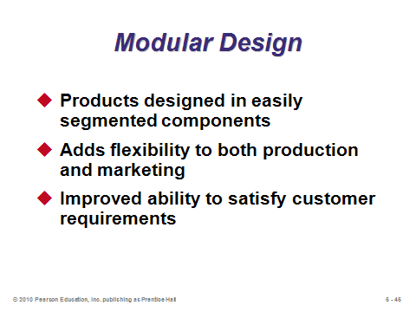

**5-44 5-45 5-46**

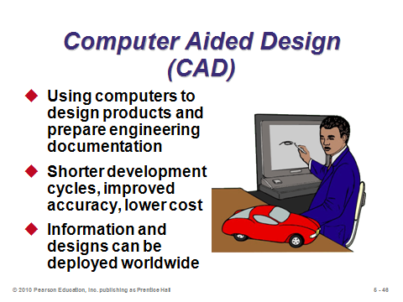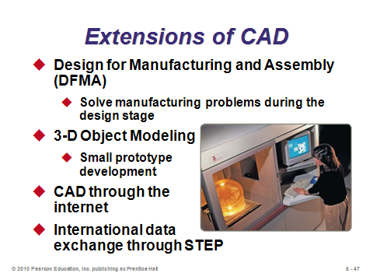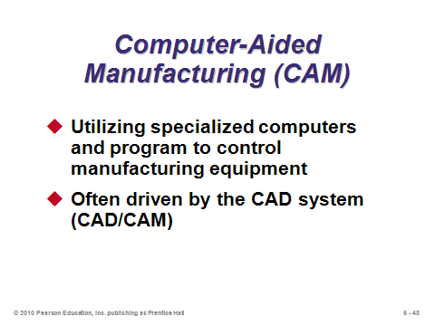

**5-47 5-48 5-49**

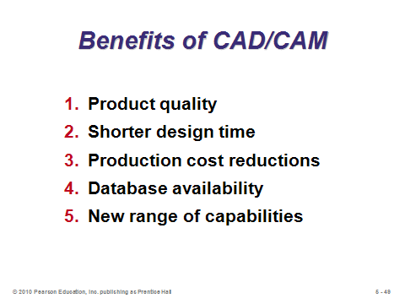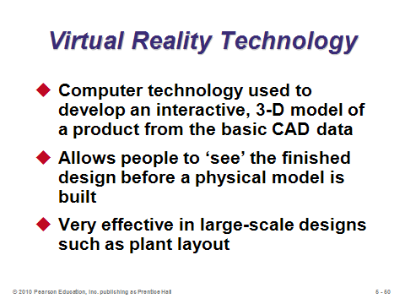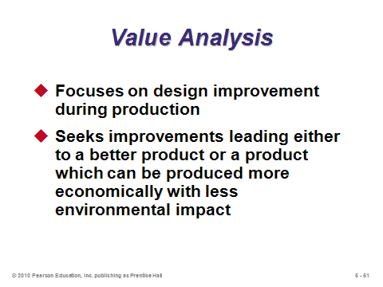

**5-50 5-51 5-52**

ETHICS, ENVIRONMENTALLY FRIENDLY DESIGNS, AND SUSTAINABILITY (5-53 through 5-61)

Slides 53-54: *Sustainability* refers to a production system that supports conservation and renewal of resources. Operations managers have an opportunity to preserve resources throughout a product’s life, from design, through production, and finally destruction.

Slide 55: BMW uses parts made of recycled plastics (blue) and parts that can be recycled (green).

Slide 56: A “systems” perspective means firms should view a product in terms of its impact on sustainability. Firms can conduct a *life cycle assessment*, which assesses the environmental impact of a product, from material and energy inputs to disposal and environmental releases.

Slides 57-58: Slide 57 identifies goals for ethical, environmentally friendly designs. Slide 58 provides guidelines to help operations managers achieve ethical and environmentally friendly designs.

Slides 59-61: Law and industry standards can help operations managers make ethical and socially responsible decisions. These slides identify some of the sources of these standards in design (Slide 59), manufacture/assembly (Slide 60), and disassembly/disposal (Slide 61).

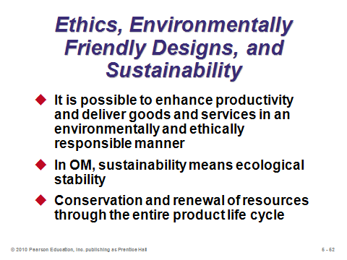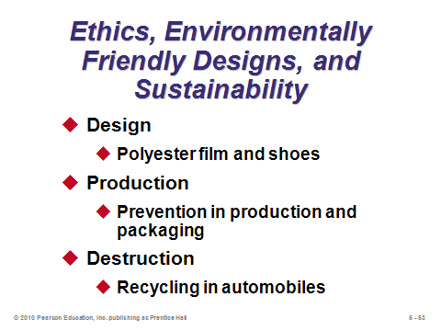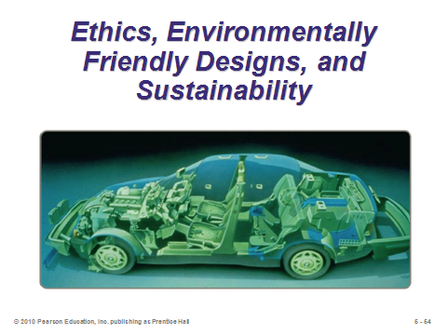

**5-53 5-54 5-55**

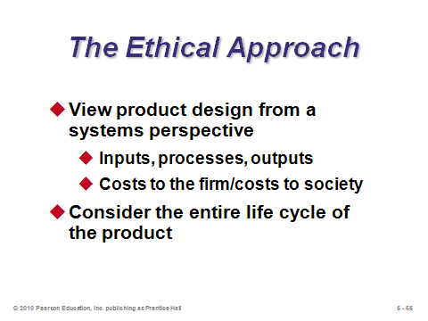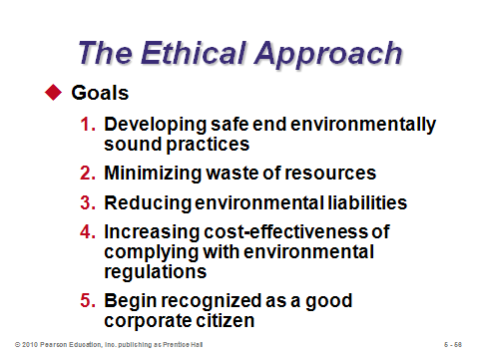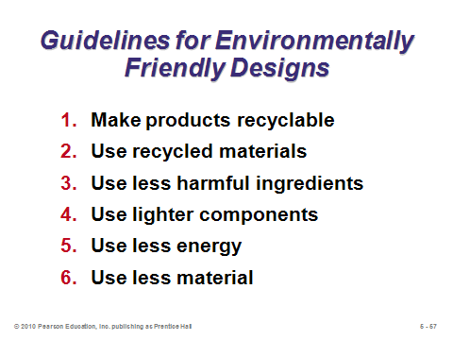

**5-56 5-57 5-58**

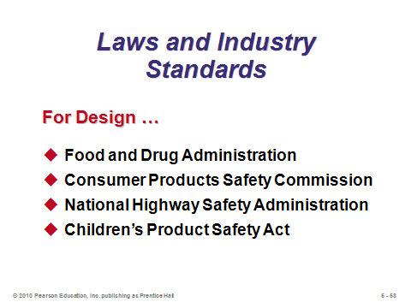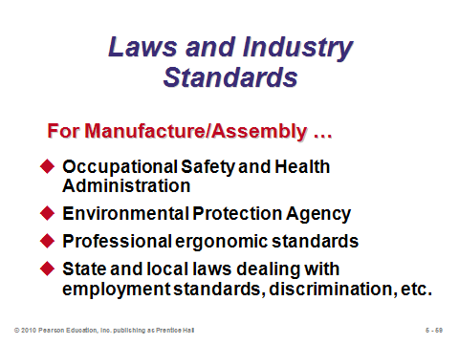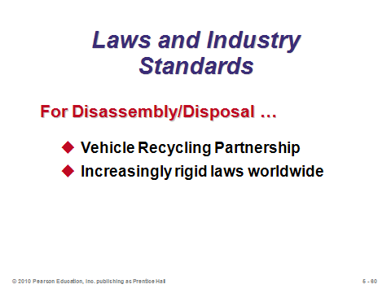

**5-59 5-60 5-61**

TIME-BASED COMPETITION (5-62 through 5-64)

Slide 62: *Time-based competition* refers to rapidly developing products and moving them to market.

Slide 63: Not all new products need to be produced from scratch. Particularly when fast development speed is crucial, other strategies may make more sense. This slide (Figure 5.6) shows a continuum that goes from new, internally developed products (on the lower left) to “alliances” (on the upper right). The cost, speed, and risk of product development all vary depending on the strategy chosen.

Slide 64: This slide describes the three *external* development strategies.

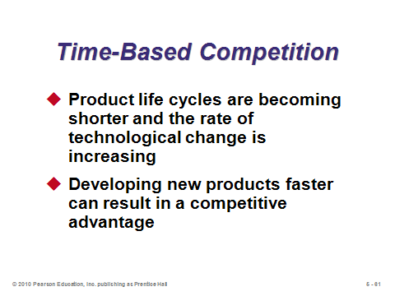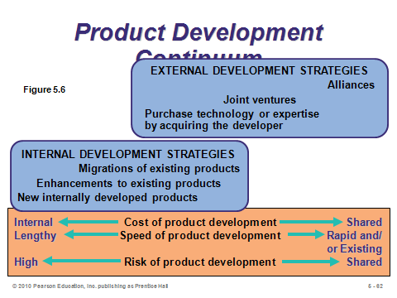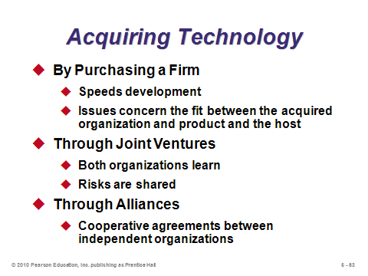

**5-62 5-63 5-64**

DEFINING A PRODUCT (5-65 through 5-73)

Slides 65-70: Before anything can be produced, a product’s functions and attributes must be defined. Two important product documents are the *engineering drawing* and the *bill of material*, as described in Slide 66. An engineering drawing shows how to make one item on the bill of material. As an example of product specifications, Slide 67 (Figure 5.7) shows a portion of the general requirements for the U.S. grades of Monterey cheese. Slide 68 (Figure 5.8) provides an example of an engineering drawing. Slide 69 (Figure 5.9(a)) displays a bill of material for a manufactured item. Subassemblies and components are indented. Slide 70 (Figure 5.9(b)) shows a bill of material for a restaurant.

Slides 71-73: The idea of *group technology* is to place products into families based on how they are manufactured, rather than perhaps on how they function or what they look like. Activities and machines can then be grouped around these families. Slide 72 (Figure 5.10) provides an example of grouping based on how those parts are made. Slide 73 identifies potential benefits of using group technology.

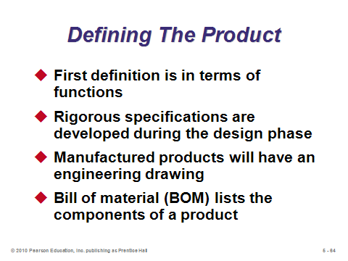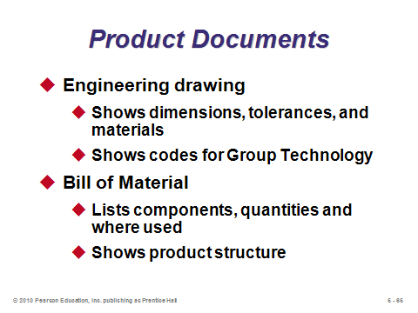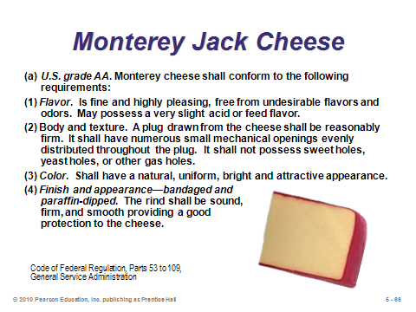

**5-65 5-66 5-67**

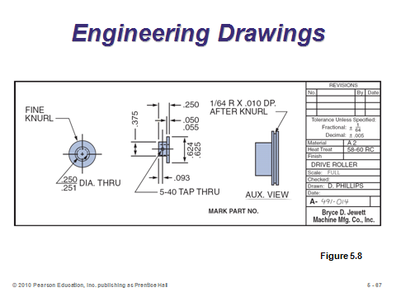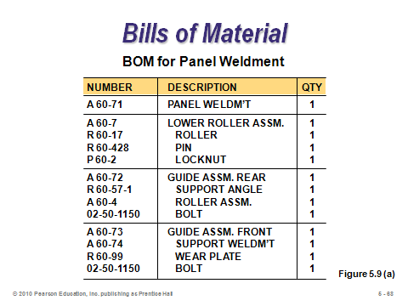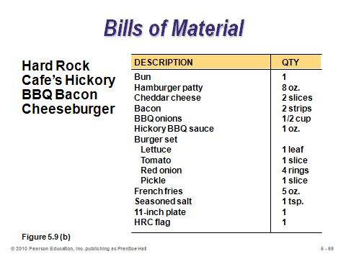

**5-68 5-69 5-70**

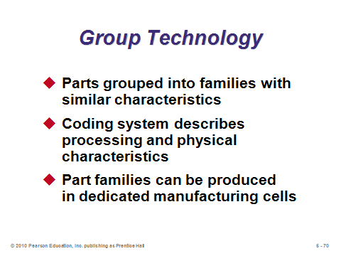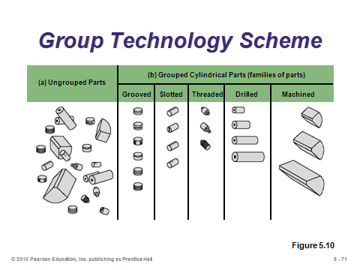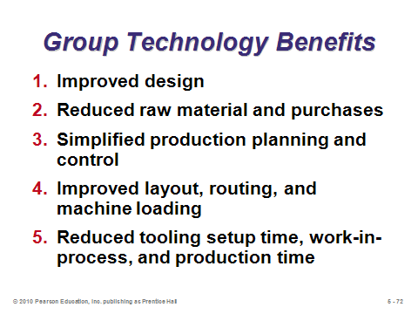

**5-71 5-72 5-73**

DOCUMENTS FOR PRODUCTION (5-74 through 5-81)

Slide 74-79: Once a product is selected, designed, and ready for production, that production is assisted by documents such as those identified in Slide 74. Slides 75-79 provide a description of each one, respectively.

Slide 80: *Configuration management* is put in place to keep the use of engineering change notices from getting out of hand or lost in the shuffle.

Slide 81: *Product life-cycle management* is an umbrella of software programs that attempts to bring together phases of product design and manufacture. The idea is that product design and manufacture decisions can be performed more creatively, faster, and more economically when the data are integrated and consistent.

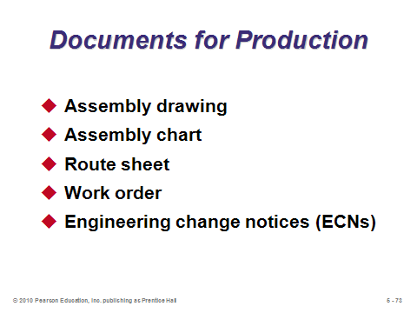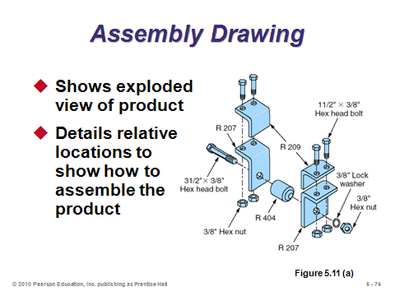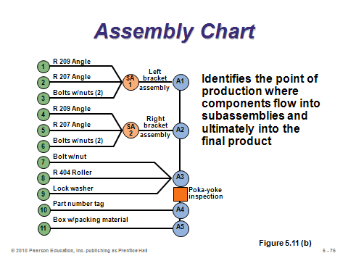

**5-74 5-75 5-76**

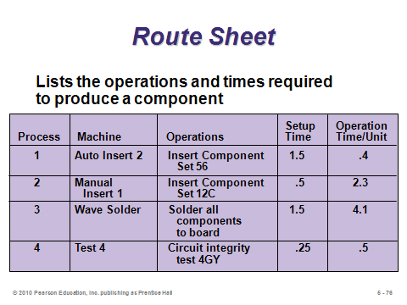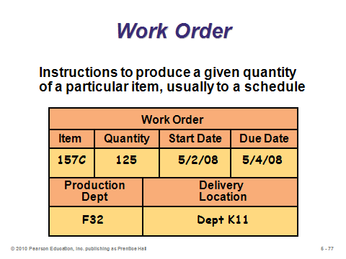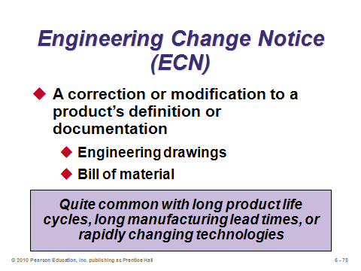

**5-77 5-78 5-79**

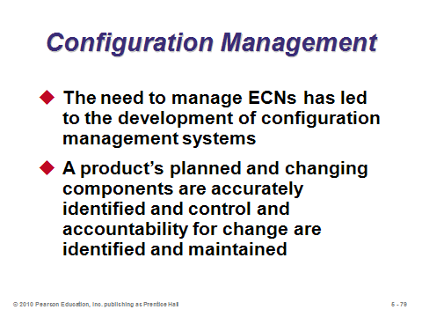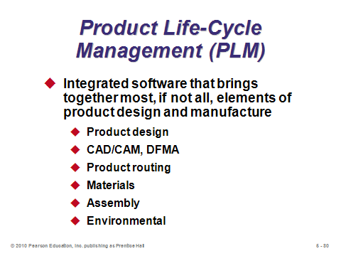

**5-80 5-81**

SERVICE DESIGN (5-82 through 5-88)

Slide 82: Designing services is challenging because they often have unique characteristics. Because the customer may be directly involved, customization is more likely to be possible but at the cost of reduced productivity. Customization can be maintained but at a lower cost by (1) delaying customization, (2) modularizing using standard modules that are combined according to customer wishes, or (3) dividing the service into small parts and automating those parts that can be (e.g., ATM machines at banks).

Slides 83-84: From Figure 5.12, we see that, in services, customers may participate in design, delivery, or both.

Slide 85: In a service business, a *moment of truth* exemplifies, enhances, or detracts from the customer’s expectations. The operation manager’s task is to identify moments of truth and design operations that meet or exceed the customer’s expectations.

Slide 86: This slide (Figure 5.13) shows a moment-of-truth analysis for a computer company’s customer service hotline.

Slide 87: Because of the high customer interaction of most services, the documents for moving the product to production are different from those used in goods-producing operations.

Slide 88: From Example 2 in the text, this slide shows service documentation for a drive-up service teller window.

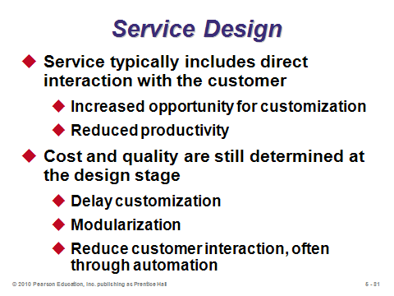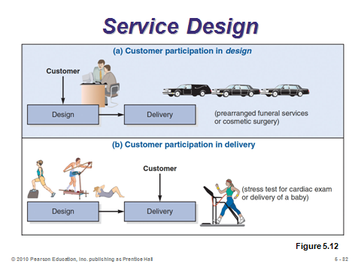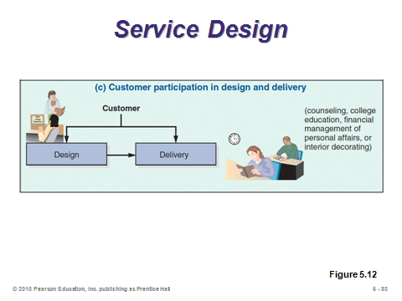

**5-82 5-83 5-84**

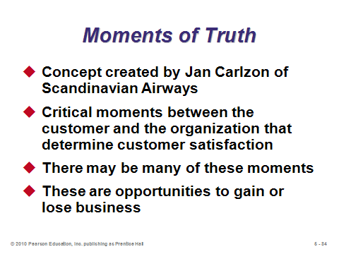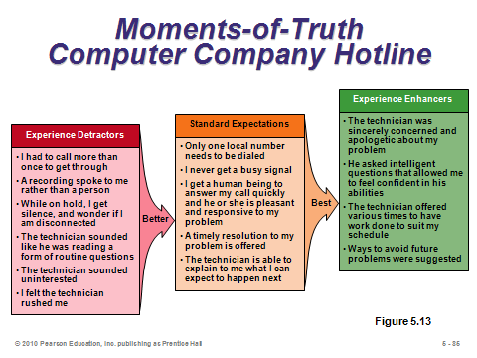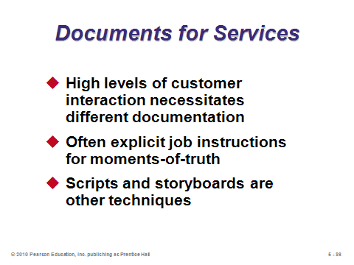

**5-85 5-86 5-87**

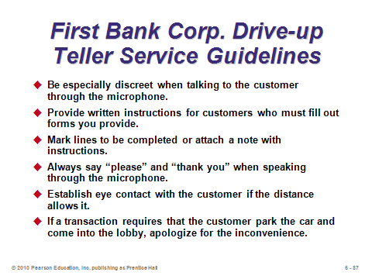

**5-88**

APPLICATION OF DECISION TREES TO PRODUCT DESIGN (5-89 through 5-94)

Slides 89-90: A decision tree is a great tool for thinking through a problem. It can be used to help make new-product decisions, especially when there are sequential decisions and outcomes. Slide 90 describes the procedures. More detailed information about decisions trees can be found in Module A.

Slides 91-94: These slides illustrate Example 3 from the text. With this analysis, the best decision appears to be to produce the microprocessor and purchase the CAD system. Comparing the two options of purchasing the CAD system or hiring and training engineers, the revenue is the same under either option depending on the favorability of the market, but the costs will be different. A decision tree makes the analysis very clear.

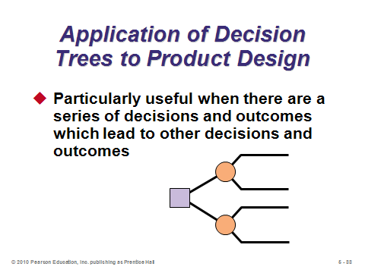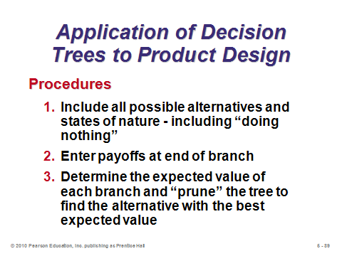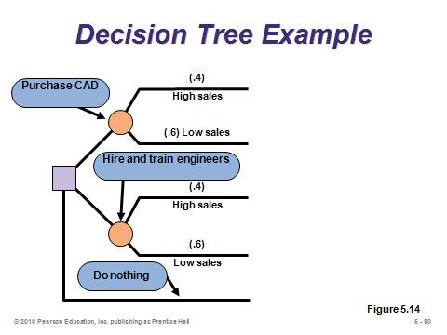

**5-89 5-90 5-91**

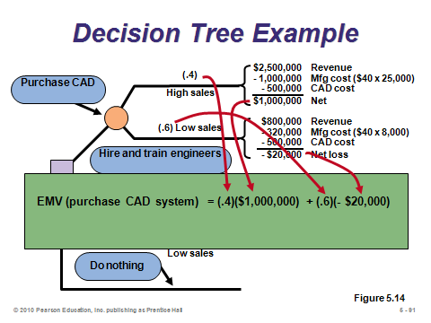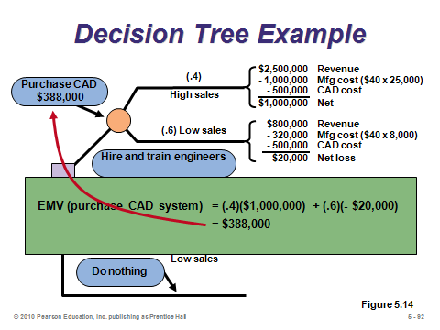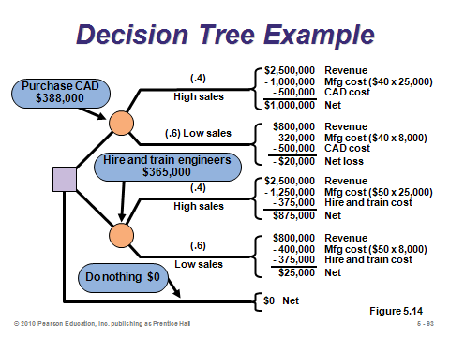

**5-92 5-93 5-94**

TRANSITION TO PRODUCTION (5-95 through 5-96)

Slides 95-96: As a firm can tinker indefinitely with a product in search of improvement, one of the arts of management is knowing when a product should move from development to production. These slides describe some of the issues involved. The operation manager’s job is to make the transition from R&D to production seamless or as smooth as possible.

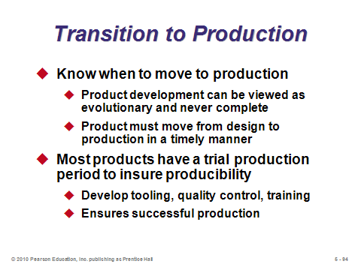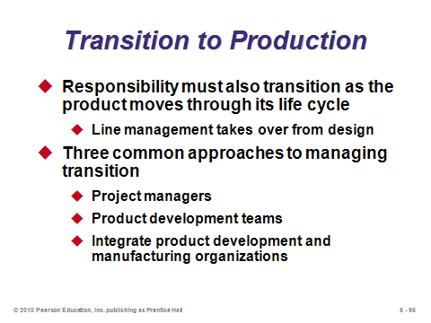

**5-95 5-96**

**Additional Assignment Ideas**

1. Some companies are known for their new products and services resulting from superior research and development. Research some of the best-known corporate R&D labs, such as 3M and Intel, and read about some of their research activity. Also, be sure to visit the Post-it Note story at 3M. Write a brief paragraph describing design process at any site you select.
   * 3M R&D: http://www.3m.com
   * Post-it Note story: http://www.3m.com/us/office/postit/pastpresent/history_ws.html
   * Moore's law is featured at: http://www.intel.com/technology/mooreslaw/index.htm
   * and also at: http://www.intel.com/pressroom/archive/speeches/GEM93097.HTM

2. Browse through a local retail store such as Wal-Mart and try to identify a product that seems to havae a poor design. How might the design be improved?

**Additional Case Studies**

Harvard Case Studies (http://harvardbusinessonline.hbsp.harvard.edu)

* *The Ritz-Carlton* (#601-163): Allows students to examine innovation and service improvement in the hospitality industry.
* *Product Development at Dell Computer Corp*. (#699-010): Focuses on how Dell redesigned its new-product development process.
* *Innovation at 3M Corp. (A)* (#699-012): Describes how 3M Corp.'s new-product development process obtains customer input.
* *CIBA Vision: The Daily Disposable Lens Project (A)* (#696-100): Examines CIBA Vision's evaluation of a new low-cost disposable contact lens.
* *Apple Powerbook (A)* (#994-023): Examines competing priorities of design and time-to-market considerations.
* *BMW: The 7-Series Project (A)* (#692-083) Evaluating a proposal to change prototype development to a method that will better identify potential production problems.

**Internet Resources**

|  |  |
| --- | --- |
| Agile Manufacturing Project at MIT | web.mit.edu/ctpid/www/agile/atlanta.html |
| Centre for Design at the Royal Melbourne Institute of Technology | www.cfd.rmit.edu.au/ |
| Concurrent Engineering Virtual Environment Demo: University of Hertfordshire | http://www.ider.herts.ac.uk/ider/ |
| Consortium on Green Design and Manufacturing | cgdm.berkeley.edu |
| EH&S Management Systems Center | ems-hsms.com |
| Examples of bad design | www.baddesigns.com |
| Green Design Initiative at Carnegie Mellon University | www.ce.cmu.edu/GreenDesign/ |
| Design Safety Engineering Risk Assessment Software, Training, and Consulting | www.designsafe.com |

**Other Supplementary Material**

Videos

1. *Disclosure*, Michael Douglas. The organization’s underlying problem is a failure to align manufacturing technologies and process choices with design requirements leading to significant performance problems.

2. *Apollo 13*, Tom Hanks. Fabricating new carbon dioxide filters. Topics: component part commonality, disaster recovery, innovative problem solving.

3. *The Best of Red Green*: Red adds gull wing doors to Ford with Duct tape. Topics: Product design, quality.

4. *Harvey Girls*: Judy Garland and colleagues demonstrate the Harvey way. Topics: Service and operations design.

5. Films available from:

Society of Manufacturing Engineers

One SME Drive

P.O. Box 930

Dearborn, Michigan 48121-0930

(P) 313-425-3000

(F) 313-425-3412

http://www.sme.org

* *Concept Modeling*: Examination of concept modeling machines and their growing impact on new product development. Order #Pl-VT665-3456.
* *DFM-Design for Manufacturing*: Storage Technology, Caterpillar, Inc. Xerox, and IBM use DFM. Order # P1-VT396-3456.
* *Rapid Injection Mold Tooling*: Learn how rapid tooling can save time and money. Order # P1-VT670-3456.
* *Solid Modeling*: Explores the rapidly developing field of solids modeling. Order # PI-VT656-3456.